北京航空航天大学

2010 ～ 2011 学年 第 一 学期

《数字电路与系统》期末考试 补考 试卷

（ 2011 年 3 月 3 日）

班级：__________；学号：______________；姓名：__________________；成绩：___________

注意事项： | 1．试题内容以中文为准，英文翻译仅供参考！  2．绘制电路原理图可以采用美标符号，也可以采用国标符号。
DISCLAIMER： | The Contents of Examination Paper in Chinese SHALL PREVAIL.  English Translation is for Reference ONLY!
计分栏：
1  （10分） | 2  （10分） | 3  （15分） | 4  （15分） | 5  （15分） | 6  （20分） | 7  （15分） | 合计

1、（共10分，每题2分）判断各题正误，正确的在括号内记“√”,错误的在括号内记“×”。
1. (10 points, 2 points for each) Judge the following statements; mark “√” if TRUE, otherwise mark “×”.
(1) 将某个逻辑变量异或“1”等价于对它求反。 ……………………（ ）
(1) For a logical variable A, 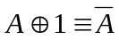.

(2) 任意组合逻辑函数都可以被表示为最大项之和的形式。…………（ ）
(2) Any of combinational logic functions can be expressed by the sum of max-terms.

(3) 施密特触发器有两个能够自行保持的稳定状态。…………………（ ）
(3) A Schmitt Trigger has two stable states that can be self-hold.

(4) 容量为n²×m的PROM可以实现任意m个输出变量的n变量组合逻辑函数。 …………………………………………………………………（ ）
(4) For a PROM chip with the capability of 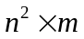 can perform any of combinational logic functions with n input variables and m output variables.

(5) 用高电平表示逻辑1状态，用低电平表示逻辑0状态，被称为正逻辑。……………………………………………………………………（ ）
(5) It’s called the positive logic assumption to let high voltage level stand for “1” and to let low voltage level stand for “0”.

2、（10分，每空2分）填空题
2. (10 points, 2 points for each blank) Fill in the blanks.
(1) 将十进制小数 0.6875 用二进制表示为：( )₂；将这个数乘以十进制整数256，得到的数值以16进制表示为：( )₁₆ 。
(1) For a decimal number 0.6875, it can be expressed in binary as: ( )₂; and if this number is multiplied by a decimal integer 256, the result can be expressed in hexadecimal as: ( )₁₆ .

(2) 对于图2-1中的电路，判断输出Y_{a}, Y_{b},为高电平还是低电平：
(2) According to the circuits showed by fig. 2-1, identify the output of Y_{a}, Y_{b} whether HIGH levels or LOW levels.
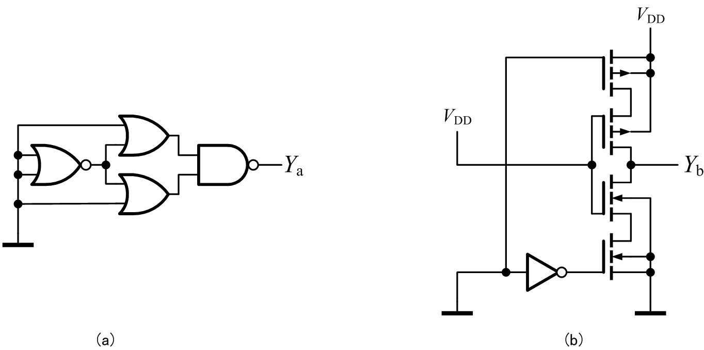
图2-1

Y_{a}为___________电平； | Y_{b}为___________电平。

(3) 设某种D/A转换器的模拟量输出范围为0V~8V，当数字量输入(d₇d₆d₅d₄d₃d₂d₁d₀)=(1010 0000)₂的时候模拟量输出5V，则当数字量输入为(d₇d₆d₅d₄d₃d₂d₁d₀)=(0111 0000)₂时，模拟量输出值为__________V。
(3) For a D/A converter with the analog output range from 0V to 8V, when the digital input (d₇d₆d₅d₄d₃d₂d₁d₀) is (1010 0000)₂ , the output is measured as 5V. Then if the digital input (d₇d₆d₅d₄d₃d₂d₁d₀) is set (0111 0000)₂ , the expected output voltage is equal to ________V.

3、（15分）由 3-8译码器 以及 与非门 组成的逻辑电路如图3-1所示，则：
3. (15 points) In fig. 3-1, there is a combinatory circuit constructed by a 3-8 decoder and two NAND logic gates. The questions are:

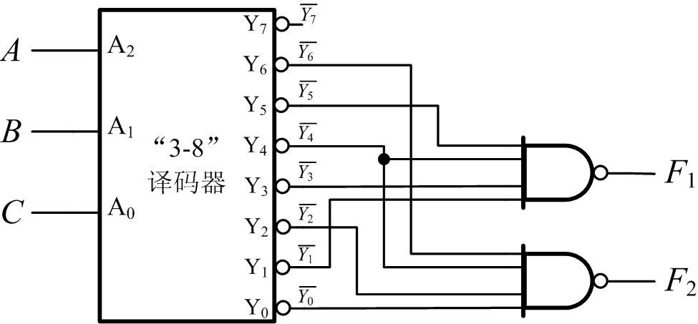
图3-1

(1) 写出最小项之和形式的逻辑函数F₁(A,B,C)和F₂(A,B,C)；
(1) Find and write down the logic functions F₁(A,B,C) and F₂(A,B,C) in the form of “the sum of min-terms”;

(2) 将F₁和F₂化简为最简“与或”表达式；
(2) Change the form of the functions F₁ and F₂ to the simplest “AND-OR” expressions.

(3) 设 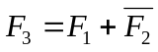，请写出F₃的最简“与或”表达式。
(3) Assuming a new logic function F₃ and , please find and write down the expression of F₃ in the form of simplest “AND-OR”.

4、（15分）电路如图4-1所示，FF₁和FF₂为边沿触发D触发器，初始状态Q₁和Q₂均为0，请按照给定的输入信号波形（如图4-2），绘出输出信号Q₁和Q₂端的波形。
4. (15 points) As shown in fig. 4-1, FF₁ and FF₂ are edge triggered D flip-flops. Assume their initial states are ZEROs. The input signal wave forms are given according to fig.4-2. Please draw the output signals Q₁ and Q₂ wave forms. (See the next page)
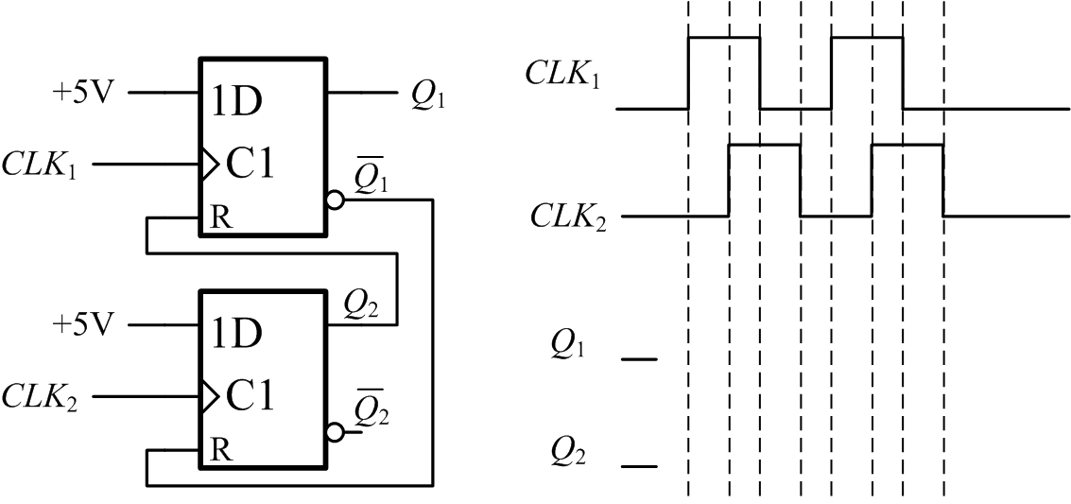

图4-1 图4-2

5、（15分）分析图5-1给出的计数器电路，74LS160为同步十进制计数器，其功能表见表5-1。请写出分析思路，并说明这是多少进制的计数器。
5. (15 points) In fig.5-1, there is a counter constructed by two 74LS160 chips, which are synchronized DECIMAL counter units and which features are showed by table 5-1. Please analyze the circuit and explain the counter how to designed, and then find the radix (i.e. the base number of a cycle) of the counter.

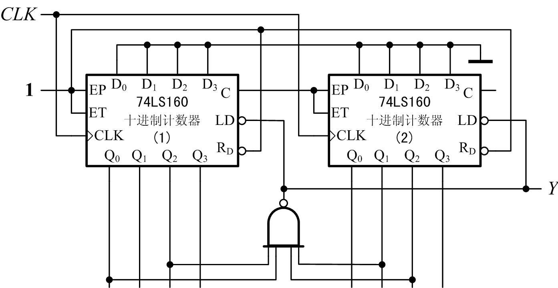

图5-1

表5-1
时钟  clock | 清零  reset | 预置  load | 使能  enable |  | 工作模式 | modes
CLK | 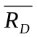 | 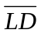 | EP | ET | 工作模式 | modes
× | 0 | × | × | × | 异步清零 | asynchronous reset
↑ | 1 | 0 | × | × | 同步预置数 | synchronous-loading
× | 1 | 1 | 0 | 1 | 保持 | holding
× | 1 | 1 | × | 0 | 保持  (但C=0) | holding  (but carry output is 0)
↑ | 1 | 1 | 1 | 1 | 加法计数 | addition counting

6、（20分）现有 4个正边沿触发的JK触发器 和 若干 与非门 器件，请设计十一进制减法计数器，该计数器的状态转换图如图6-1所示。
6. (20 points) Design a synchronous sequential logic circuit with four positive edge triggered J-K flip-flops and several NAND gates. The State Transition Diagram is showed in fig. 6-1. As the figure, it’s a BACKWARD counter in the base number of ELEVEN.

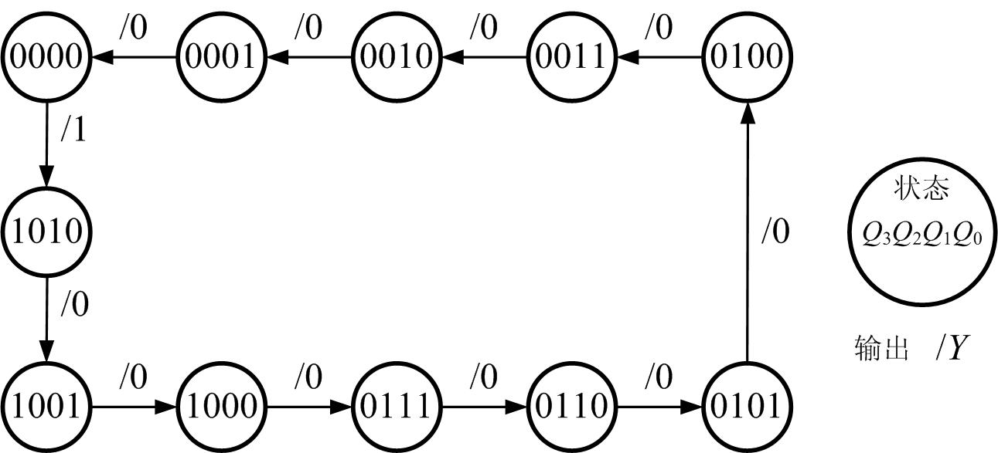
图6-1
(1) 写出 状态方程、驱动方程 和 输出方程，并进行化简；
(1) Write down your design’s state equations, output equation and driving equations; make some simplifications if possible;

(2) 绘制电路的原理图；
(2) Draw the schematic diagram of your design; (You can draw it in the space below.)

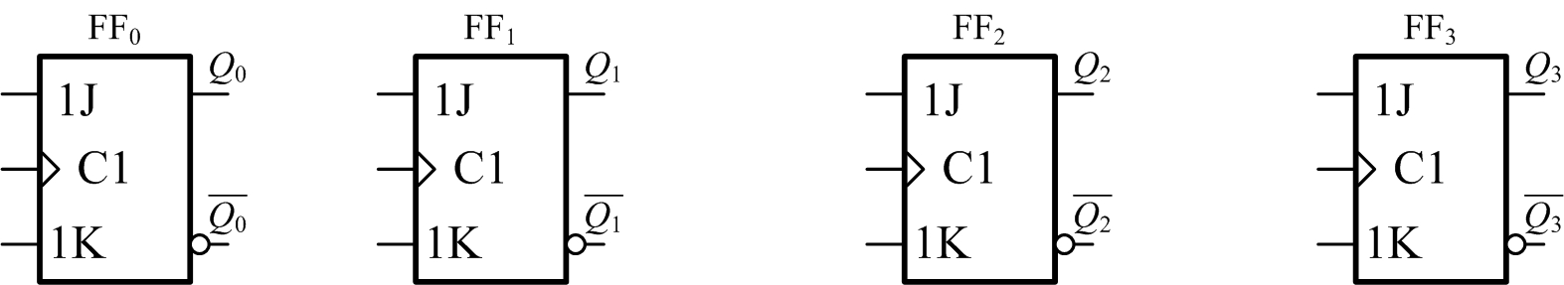

(3) 检查是否能够自启动，并说明理由。
(3) Check whether your design is self-starting or not; give some reasons and show the result of the checking.

7、（15分）单稳态触发器
7. (15 points) Mono-stable vibrator.
(1) 图7-1所示的电路是CMOS门电路构成的微分型单稳态触发器，CMOS门限V_{TH}=V_{DD}/2，输出电平V_{OL}≈0，V_{OH}≈V_{DD}，且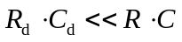，试根据 图7-2 中（见下页）触发信号v_{I}的波形，绘出v_{d}、v_{O1}、v_{I2}和v_{O}的波形；
(1) As shown in fig. 7-1, there is a differential mono-stable vibrator, also called “one-shot”, implemented by CMOS gates. The threshold V_{TH} of COMS gates is equal to V_{DD}/2, the low level V_{OL}≈0 and the high level V_{OH}≈V_{DD}, in which V_{DD} is the power voltage.
According to the wave form of input signal v_{I} shown in fig. 7-2 (see the next page), draw the stimulated wave forms of v_{d} , v_{O1} , v_{I2} and v_{O.}
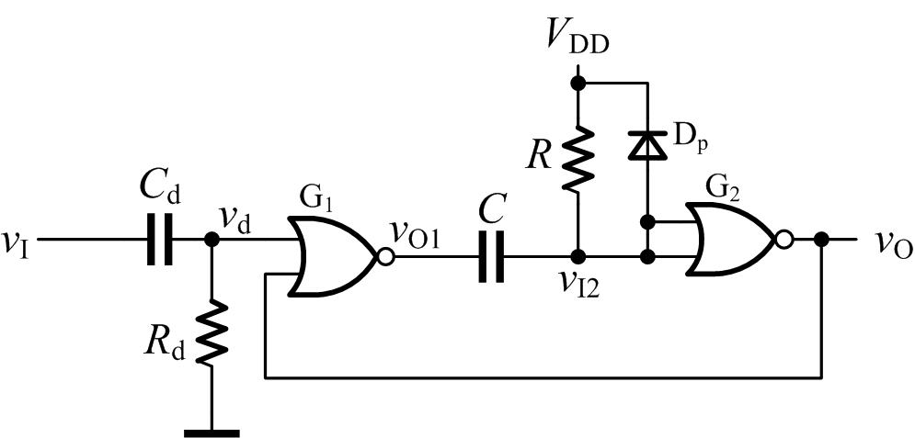
图7-1

(2) 设R=51kΩ，C=0.01μF，求单稳态触发器输出脉冲的宽度T_{W}；（计算中取 ln2 ≈0.69）
(2) Assume the following parameters in fig.7-1: R=51kΩ, C=0.01μF, please calculate the width T_{W} of the “one-short” output pulse. (ln2 ≈0.69)

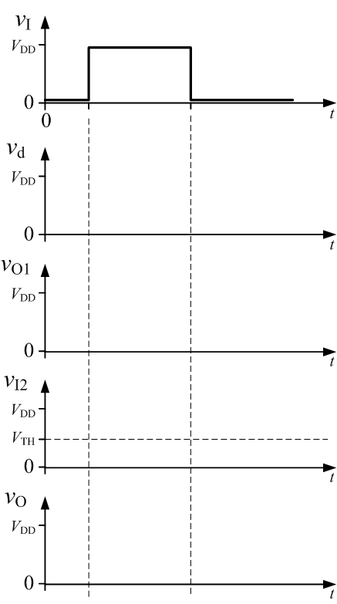
图7-2

(3) 如图7-3，对单稳态触发器的输入级进行改进，请说明该输入级电路的工作原理；
(3) Make a modification for the input stage of the “one-shot” shown in fig. 7-1 ; and the modified circuit is shown in fig. 7-3. Please discuss work principles of this new input stage and write down some remarks; （You can write down it in the next page.）
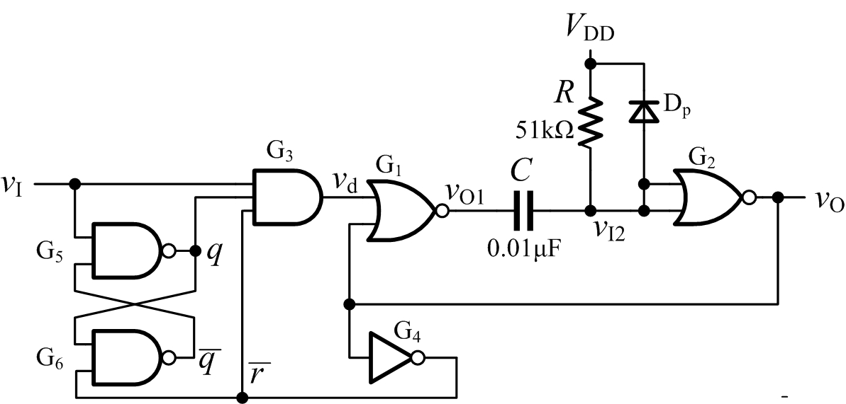

图7-3

(4) 对于图7-3所示的电路，试根据 图7-4 中触发信号v_{I}的波形，绘出输入级q、和各点（参见图7-3）的电压波形，以及输出端v_{O}的波形。
(4) According to the wave form of input signal v_{I} shown in fig. 7-4, draw the concerned voltage wave forms in nodes of , and (ref. to fig. 7-3), and the wave form of output signal v_{O.}
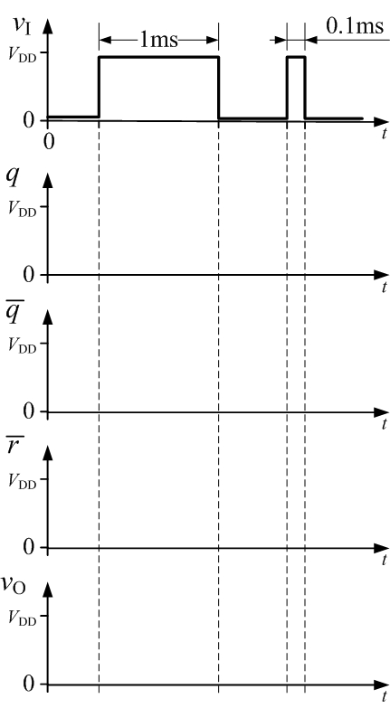
图7-4

